The Funeral will take place on Thursday 27th August at 11.30 am at Pontefract Crematorium for family members.  The cortege will leave 2A High Farm Meadow at 11.00.  Cathy Davies will be the Officiant at the funeral.  The entry music will be Celeste Aida sung by Pavarotti  Barrie  Hannah Ann’s favorite sayings  David Ann’s story  Music to remember Ann Perhaps Love sung by John Denver  Ellie Isle of Innisfree written by WB Yeats  Cathy closure  Closure music Danny Boy sung by the three Irish Tenors  Donations to Cancer Research UK  The funeral party will then leave for Darrington Golf Club where they will welcome other guests from 13.00pm |  |  | Ann was born in East Didsbury on 11 April 1940, to Margaret and Sidney Dodge. Her sister Jean was born 3 years later. Her first memory was of being taken into the garden, in the dark, to the air raid shelter (probably built by her dad). They lived at 60 Lynwood Road at the end of a cul-de-sac they called ‘The Banjo’, very close to what is now the Manchester Trams Terminus. Ann had fond memories of her school years and could recall the names of most of those in her classes, as well as many of her teachers.  She passed the 11 plus and went on to Levenshulme High School.  Ann left school at 16 and worked at The Shirley Institute, Cotton and Rayon Research Laboratories. She studied to achieve ONC and HNC on day release and ultimately became Licentiate of the Royal Institute of Chemistry. In the 1980s she was awarded an OU degree in Maths, Physics and Computing.  Ann and Barrie were introduced by Barbara and Dave Coleman, who thought they would make an ideal couple. One day Barrie telephoned Ann to invite her to a party and she liked the sound of his voice so much that she decided to say ‘yes’. Barbara, along with cousin Joan and sister Jean, was a bridesmaid at their wedding in 1962.  Vivienne was born in 1967 and Keith in 1969. Barrie was not popular because Keith’s imminent arrival coincided with the moon landing on 20 July and he was not in any hurry to take Ann to hospital in case he missed it! Ann was a counsellor with the Natural Childbirth Trust whilst the children were small - she helped some 130 couples prepare for birth and parenthood.  In 1978 the family moved across the Pennines to Yorkshire. At first, the accent was hard to fathom and Ann did not want her children to pick it up but years later Vivienne recalls phoning home and thinking – ‘too late Mum, you’ve got a Yorkshire accent now!’  [Company Name]

Sport was an important part of Ann’s life. Her school report aged 16 said she ‘has a good natural ability and with greater interest and keenness could have reached a very high standard’! Despite this, she went on to play badminton, squash, and tennis at club level, but then discovered golf, and was to while away many hours, and make many friends. She was quietly competitive and delighted in playing a good round or winning prizes.  Ann thoroughly enjoyed a wide range of culture and over the years with Barrie or the children in tow, watched or listened to ballet, theatre, opera, and jazz. She learned to play the piano as a child and recently enjoyed listening to her granddaughter Hannah play old favorites on the keyboard.  Ann and Barrie moved to Badsworth in 2000 where they dived into village life and new friendships. Ann was a great organiser, adept at cajoling people to contribute, and she helped run many village events. Outside Badsworth life, she was an attentive and diligent treasurer to Barrie’s flying group for 25 years.  Ann was proud of her family – the children have had different but successful careers, and she loved to hear about her grandchildren’s activities and achievements.  Keeping in touch with friends was important to Ann throughout her life. She loved to entertain and we think of Ann as always elegant and coordinated in dress. Her friend Elizabeth said that prior to one school reunion, the other ladies needed to know if Ann was attending as they may need to buy a new outfit to compete!  Ann will always have a very special place in our hearts. |  |  | Celebrating the Life of  Ann Margaret Slinger  April 11th 1940 ~ August 10th 2020  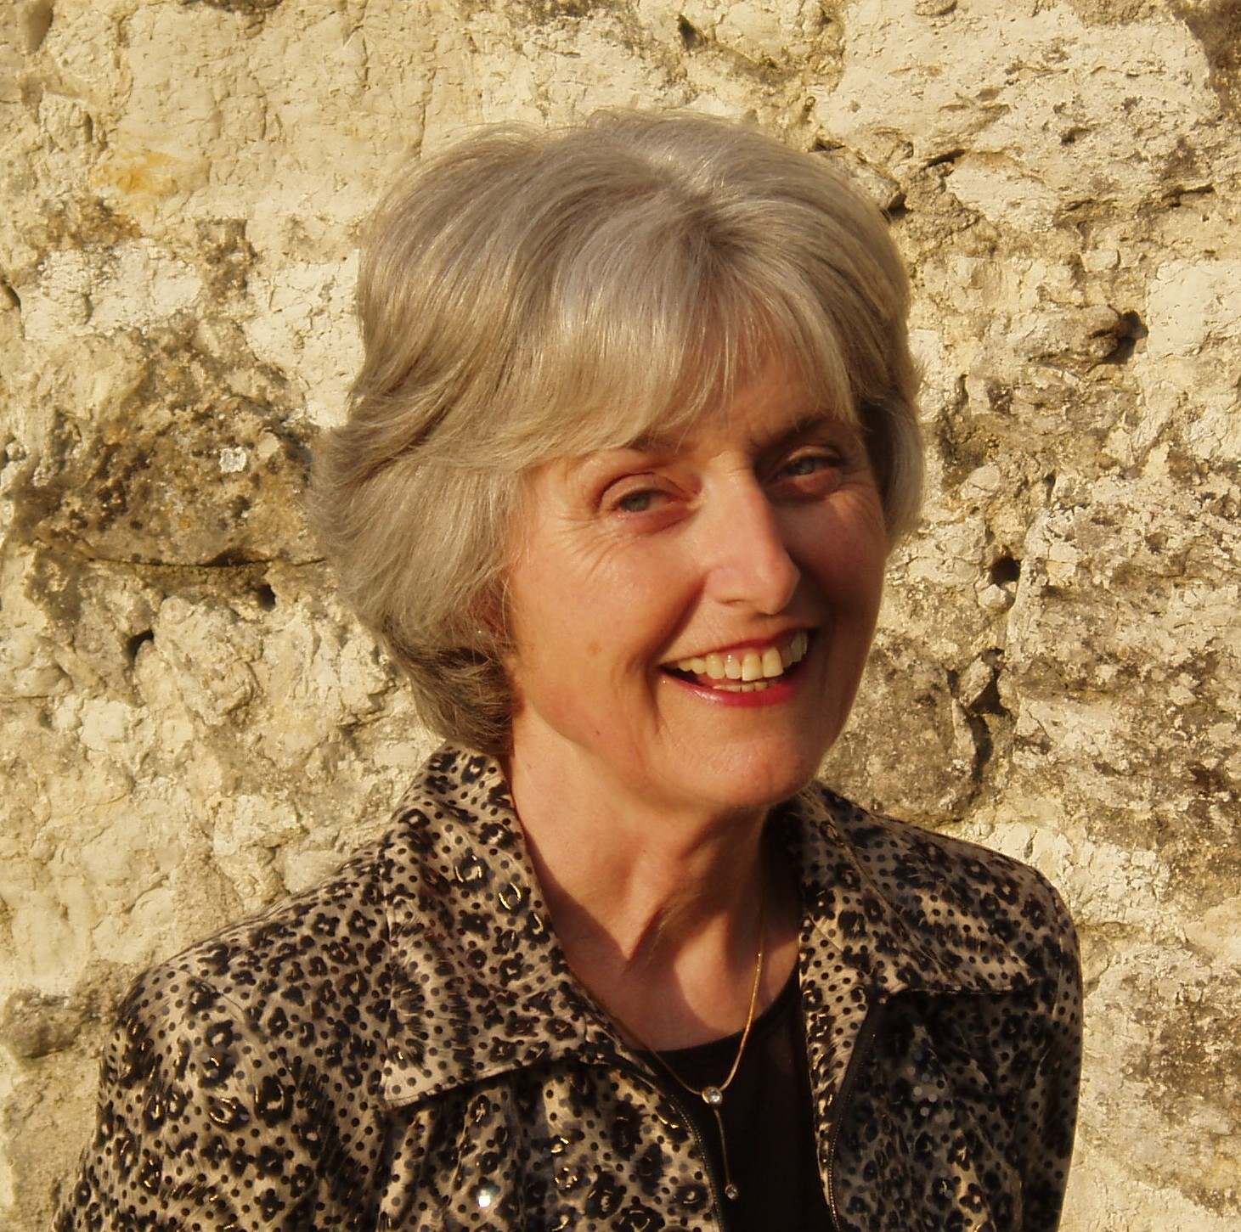

4 |  |  | 1

